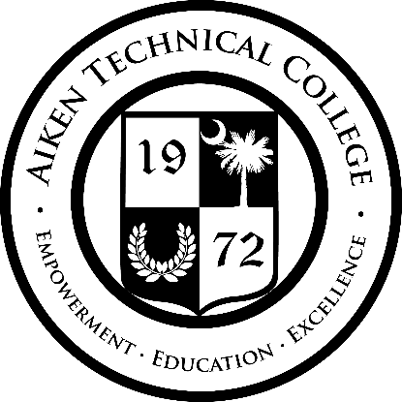
Award Date: July 29, 2021

Solicitation Number: 2021-2022-0006
Posting Date: July 6, 2021
Opening Date: July 27, 2021
Description: Strategic Planning Development
Awarded to: Robinson Management Consulting, LLC
Purchase Order #: 12143
Bid Amount: $25,000.00

____________________
Dora Robson, CPPB, NIGP-CPP
Procurement Specialist

